1. Write a program to calculate the area of circle and square.

#include<stdio.h>

#define pie 3.14

int main()

{

/*To Calculate the Area of circle and Square*/

float r,l,ac,as;

printf("Enter the radius of Circle\n");

scanf("%f",&r);

printf("Enter the length of Square\n");

scanf("%f",&l);

ac=pie*r*r;

as=l*l;

printf("The area of the Circle is= %.2f\n",ac);

printf("The area of the Square is=%.2f\n",as);

return 0;

}

**Output:**

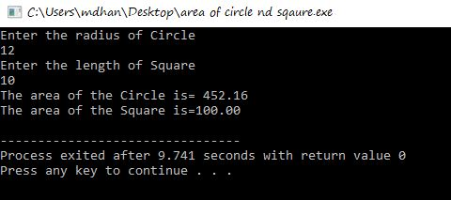

2)Write a program to find if the given number is positive or negative number.

#include<stdio.h>

int main()

{

int n;

printf("Enter any number\n");

scanf("%d",&n);

if(n>=0)

printf("The number %d is a positive number",n);

if(n<0)

printf("The number %d is a negative number",n);

return 0;

}

**Output:**

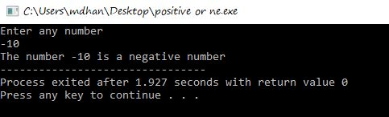

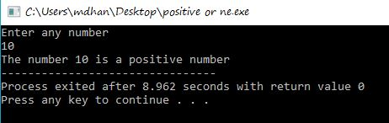

3)Write a program to calculate profit and loss.

#include<stdio.h>

int main()

{

int SP,CP,profit,loss;

printf("Enter the values of SP and CP\n");

scanf("%d%d",&SP,&CP);

if(SP>CP)

{

profit=SP-CP;

printf("The Profit is= %d",profit);

}

if(CP>SP)

{

loss=CP-SP;

printf("The Loss=is %d",loss);

}

return 0;

}

**Output:**

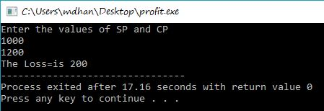

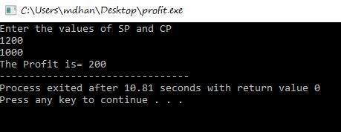

4)Write a program to find if the given number is odd or even.

#include<stdio.h>

int main()

{

int n;

printf("Enter any number\n");

scanf("%d",&n);

if(n%2==0)

printf("The number %d is an even number\n",n);

if(n%2!=0)

printf("The number %d is an odd number\n",n);

return 0;

}

**Output:**

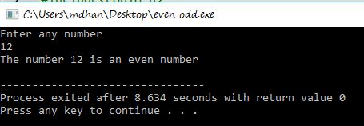

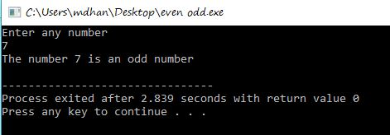

5)Write a program to find grade of students.

#include<stdio.h>

int main()

{

int marks;

printf("Enter the marks obtained\n");

scanf("%d",&marks);

if(marks<=100&&marks>=90)

printf("The obtained Grade is A+");

if(marks<=90&&marks>80)

printf("The obtained Grade is A");

if(marks<=80&&marks>70)

printf("The obtained Grade is B+");

if(marks<=70&&marks>60)

printf("The obtained Grade is B");

if(marks<=60&&marks>50)

printf("The obtained Grade is C+");

if(marks<=50&&marks>40)

printf("The obtained Grade is C");

if(marks<=40&&marks>30)

printf("The obtained Grade is D+");

if(marks<=30&&marks>20)

printf("The obtained Grade is D");

if(marks<=20&&marks>=0)

printf("The obtained Grade is E");

return 0;

}

**Output:**

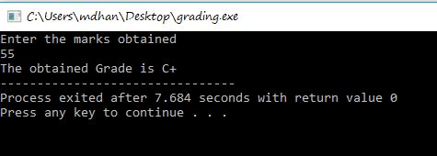

6)Write a program to find whether a person is eligible to vote or not.

#include<stdio.h>

int main()

{

int age;

printf("Enter Your Age\n");

scanf("%d",&age);

if(age>=18)

printf("You are eligible to vote");

if(age<18)

printf("You are not eligible to vote");

return 0;

}

**Output**

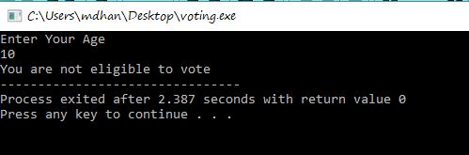

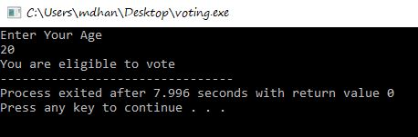

7)Write a program to perform bitwise OR,AND & XOR

#include<stdio.h>

int main()

{

int a,b;

printf("enter any two no. \n");

scanf("%d%d",&a,&b);

//for AND

printf(" AND output=%d \n ",a&b);

// for OR

printf("OR output=%d \n",a|b);

//for XOR

printf("XOR output=%d",a^b);

return 0;

}

**Output**

